**SOLUTION ARCHITECTURE**

**Design:**

* Detection of out-of-stock items and overflowing items in inventory.
* Sending mail automatically when an item in an inventory runs out.
* The amount of stock available for each product can be tracked.

**Software and system required:**

* Python
* Flask
* Docker
* 8GB RAM, Intel Core i3
* OS-Windows/Linux/MAC
* Laptop or Desktop

**Block Diagram:**

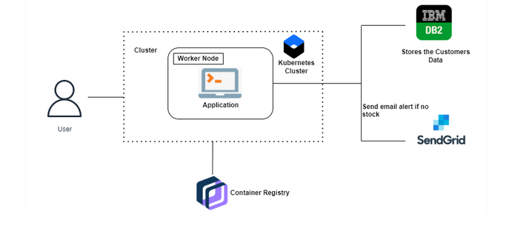

**Cloud Services:**

